**Results Template**

A Subtitle

## 0.1 Packages

# 1 Introduction

# 2 Sliding windows

import sys  
sys.path.insert(1, 'libs/')  
  
import dynfc as dyn  
import numpy as np  
from numpy.random import seed, rand  
import scipy as sc  
from scipy import io  
import seaborn as sns  
import matplotlib.pyplot as plt  
import matplotlib.cbook as cbook  
import matplotlib.cm as cm  
import matplotlib.patches as patches  
  
font = {'weight' : 'regular',  
 'size' : 24}  
plt.rc('font', **font)  
  
ts = sc.io.loadmat('data/ts.mat')['ts']  
ts = ts.transpose()  
  
corr_mats, idx = dyn.corr_slide(ts,300,50)  
  
idx.shape

> (24,)

a = [1,1,1,1,1.6]  
  
fig,ax = plt.subplots(1)  
fig.set_figheight(10)  
fig.set_figwidth(20)  
plt.style.use('tableau-colorblind10')  
for i in range(5):  
   
 plt.plot(2*i*a[i] + ts[i,]/1.4)

> [<matplotlib.lines.Line2D object at 0x7fc382a08d30>]  
> [<matplotlib.lines.Line2D object at 0x7fc28166ff28>]  
> [<matplotlib.lines.Line2D object at 0x7fc28166f940>]  
> [<matplotlib.lines.Line2D object at 0x7fc28166f780>]  
> [<matplotlib.lines.Line2D object at 0x7fc281655390>]

plt.xlabel('Time [TRs]')

> Text(0.5, 0, 'Time [TRs]')

plt.ylabel('BOLD')

> Text(0, 0.5, 'BOLD')

ax.tick_params(left=False)  
ax.set_yticklabels([])

> [Text(0, -2.0, ''), Text(0, 0.0, ''), Text(0, 2.0, ''), Text(0, 4.0, ''), Text(0, 6.0, ''), Text(0, 8.0, ''), Text(0, 10.0, ''), Text(0, 12.0, ''), Text(0, 14.0, '')]

ax.set_ylim(-3,15.4)

> (-3.0, 15.4)

ax.set_xlim(0,1200)

> (0.0, 1200.0)

rect = patches.Rectangle((idx[0],-2.8),300,18,linewidth=4,edgecolor='#595959',facecolor='none')  
ax.add_patch(rect)

> <matplotlib.patches.Rectangle object at 0x7fc23e648438>

rect = patches.Rectangle((idx[5],-2.8),300,18,linewidth=4,edgecolor='#A56B6B',facecolor='none')  
ax.add_patch(rect)

> <matplotlib.patches.Rectangle object at 0x7fc23e648c50>

rect = patches.Rectangle((idx[9],-2.8),300,18,linewidth=4,edgecolor='#CE3E3E',facecolor='none')  
ax.add_patch(rect)

> <matplotlib.patches.Rectangle object at 0x7fc23e648f60>

rect = patches.Rectangle((idx[16],-2.8),300,18,linewidth=4,edgecolor='#FF0000',facecolor='none')  
ax.add_patch(rect)

> <matplotlib.patches.Rectangle object at 0x7fc23e6502b0>

plt.show()



import sys  
sys.path.insert(1, 'libs/')  
  
import dynfc as dyn  
import numpy as np  
from numpy.random import seed, rand  
import scipy as sc  
from scipy import io  
import seaborn as sns  
import matplotlib.pyplot as plt  
import matplotlib.cbook as cbook  
import matplotlib.cm as cm  
import matplotlib.patches as patches  
  
aa = plt.figure(figsize = [6,6])  
ax = sns.heatmap(corr_mats[:,:,0],   
 cmap = "RdBu_r",   
 vmin = -1,   
 vmax = 1,   
 square = True,   
 cbar = False)  
ax.axis('off')

> (0.0, 200.0, 200.0, 0.0)

ax.tick_params(left=False, bottom=False)  
   
plt.show()

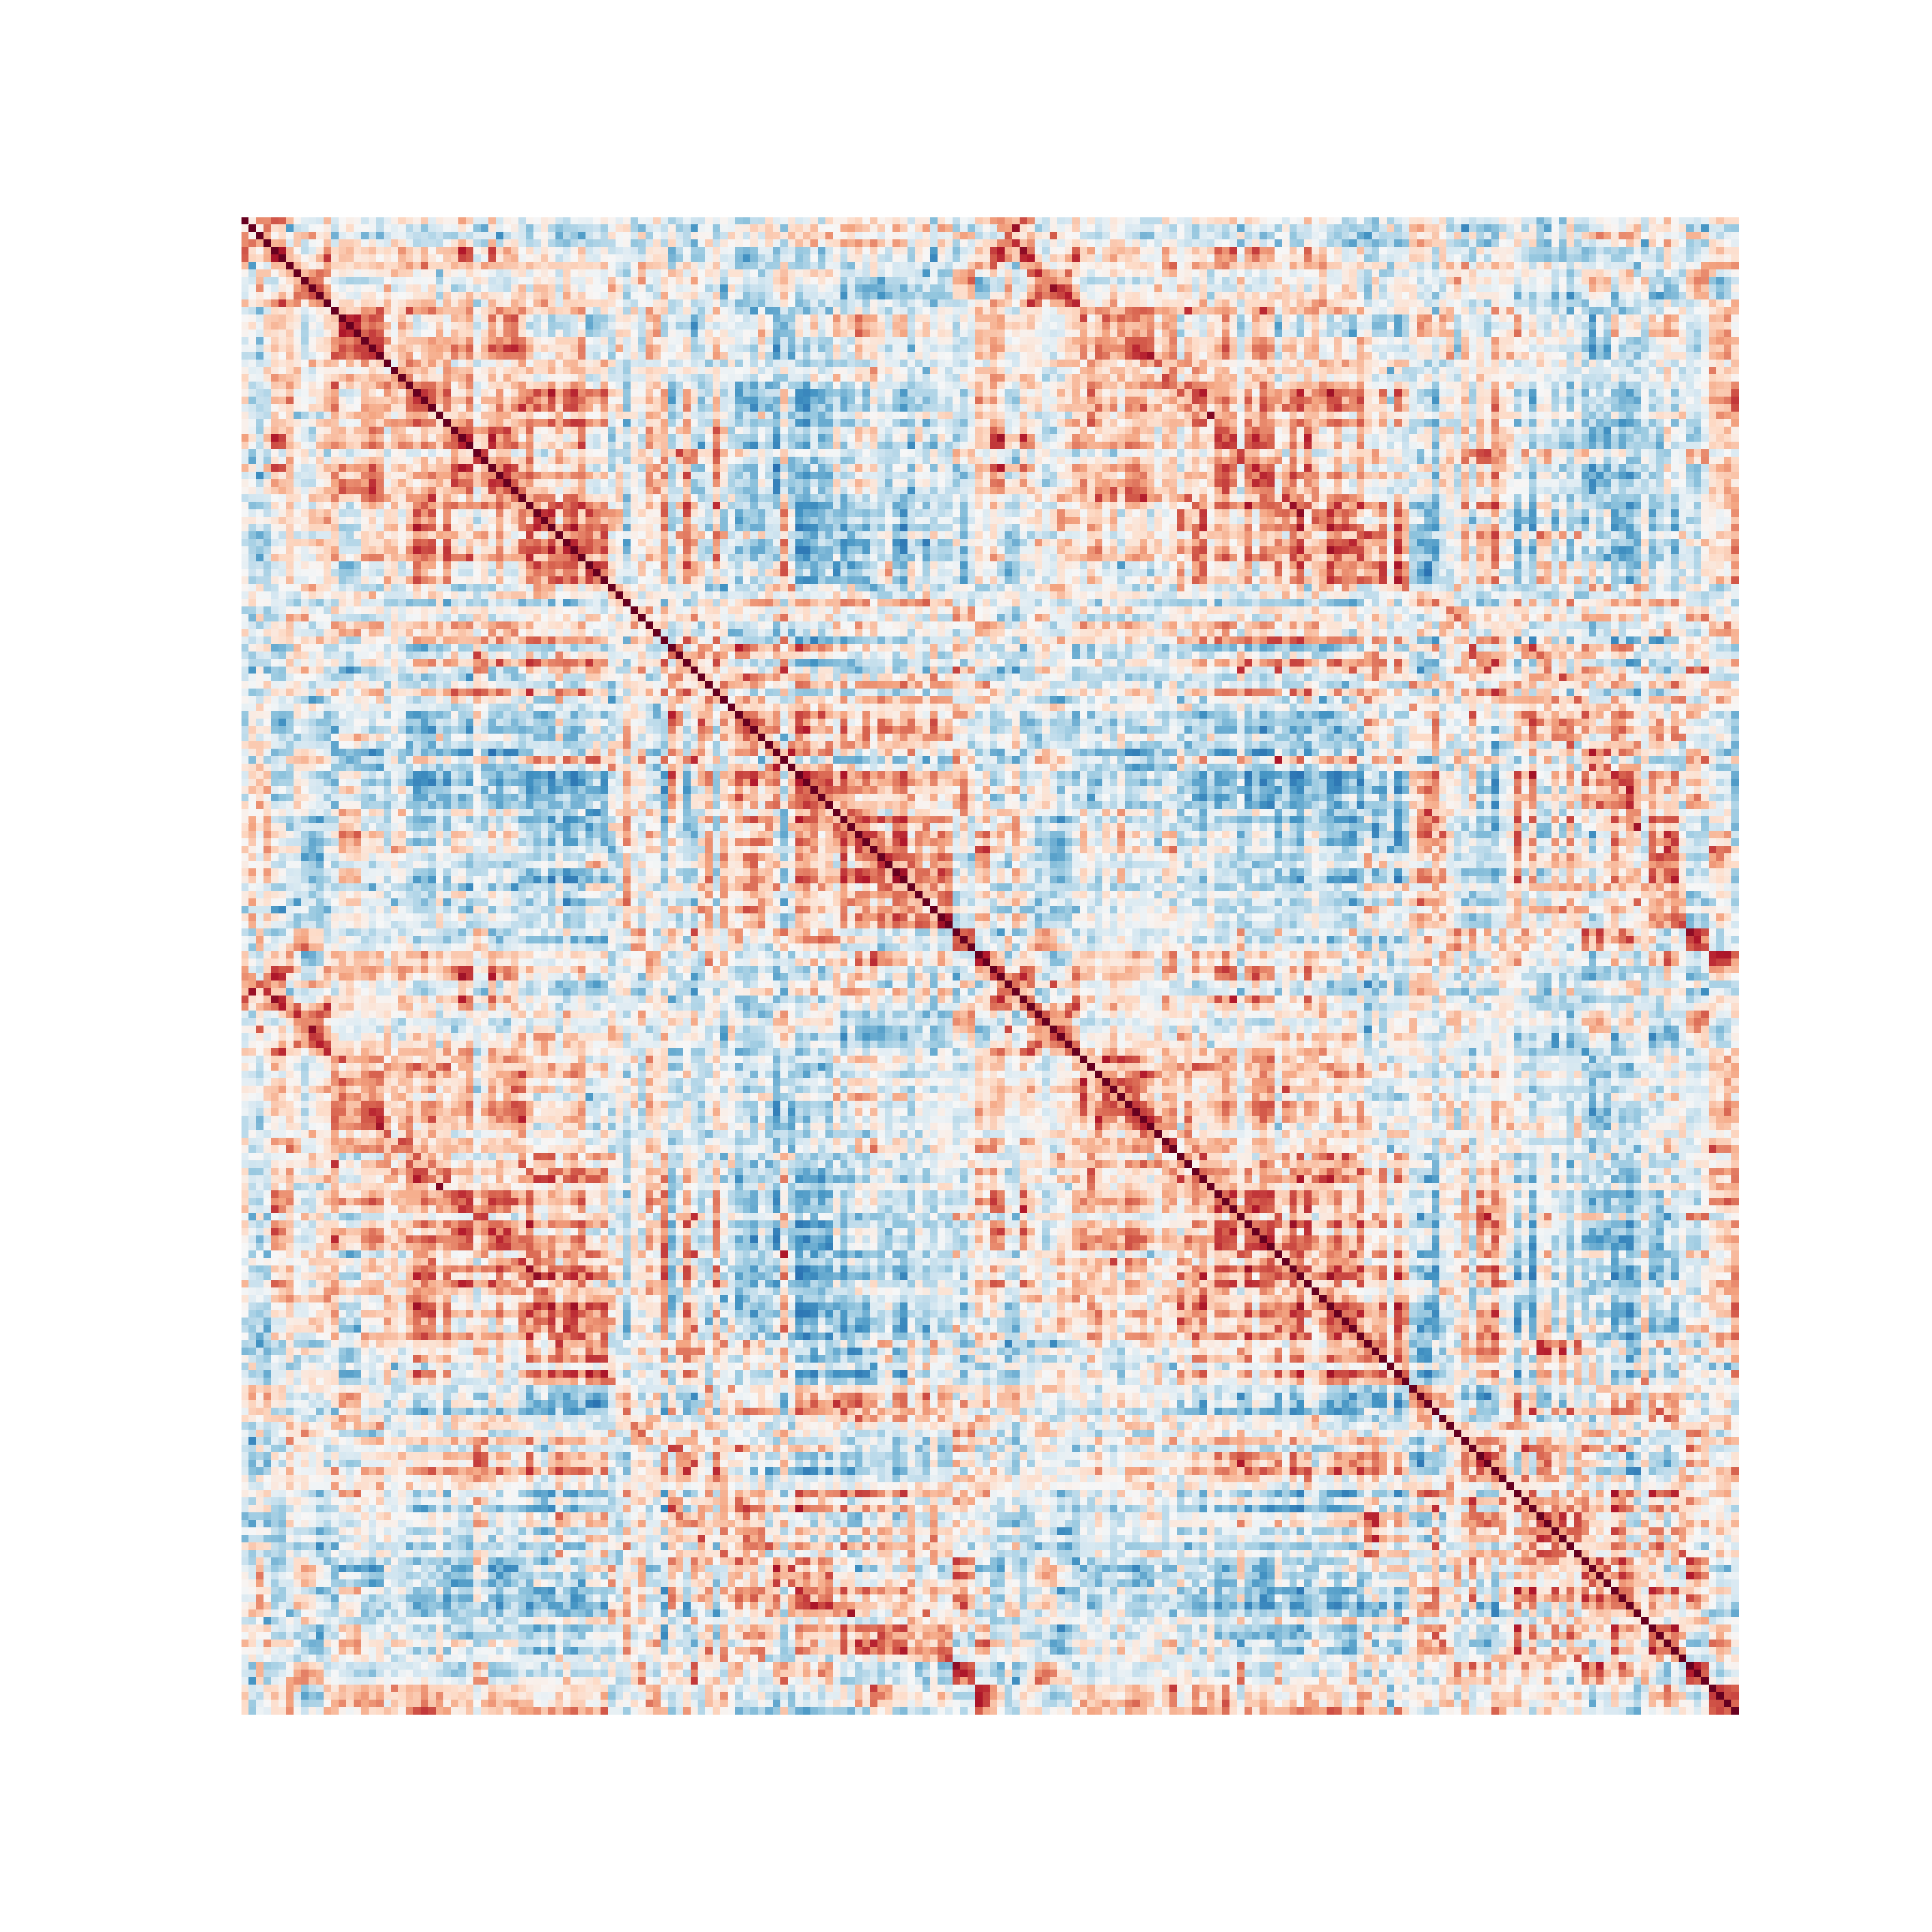

aa = plt.figure(figsize = [6,6])  
ax = sns.heatmap(corr_mats[:,:,5],   
 cmap = "RdBu_r",   
 vmin = -1,   
 vmax = 1,   
 square = True,   
 cbar = False)  
ax.axis('off')

> (0.0, 200.0, 200.0, 0.0)

ax.tick_params(left=False, bottom=False)  
   
plt.show()

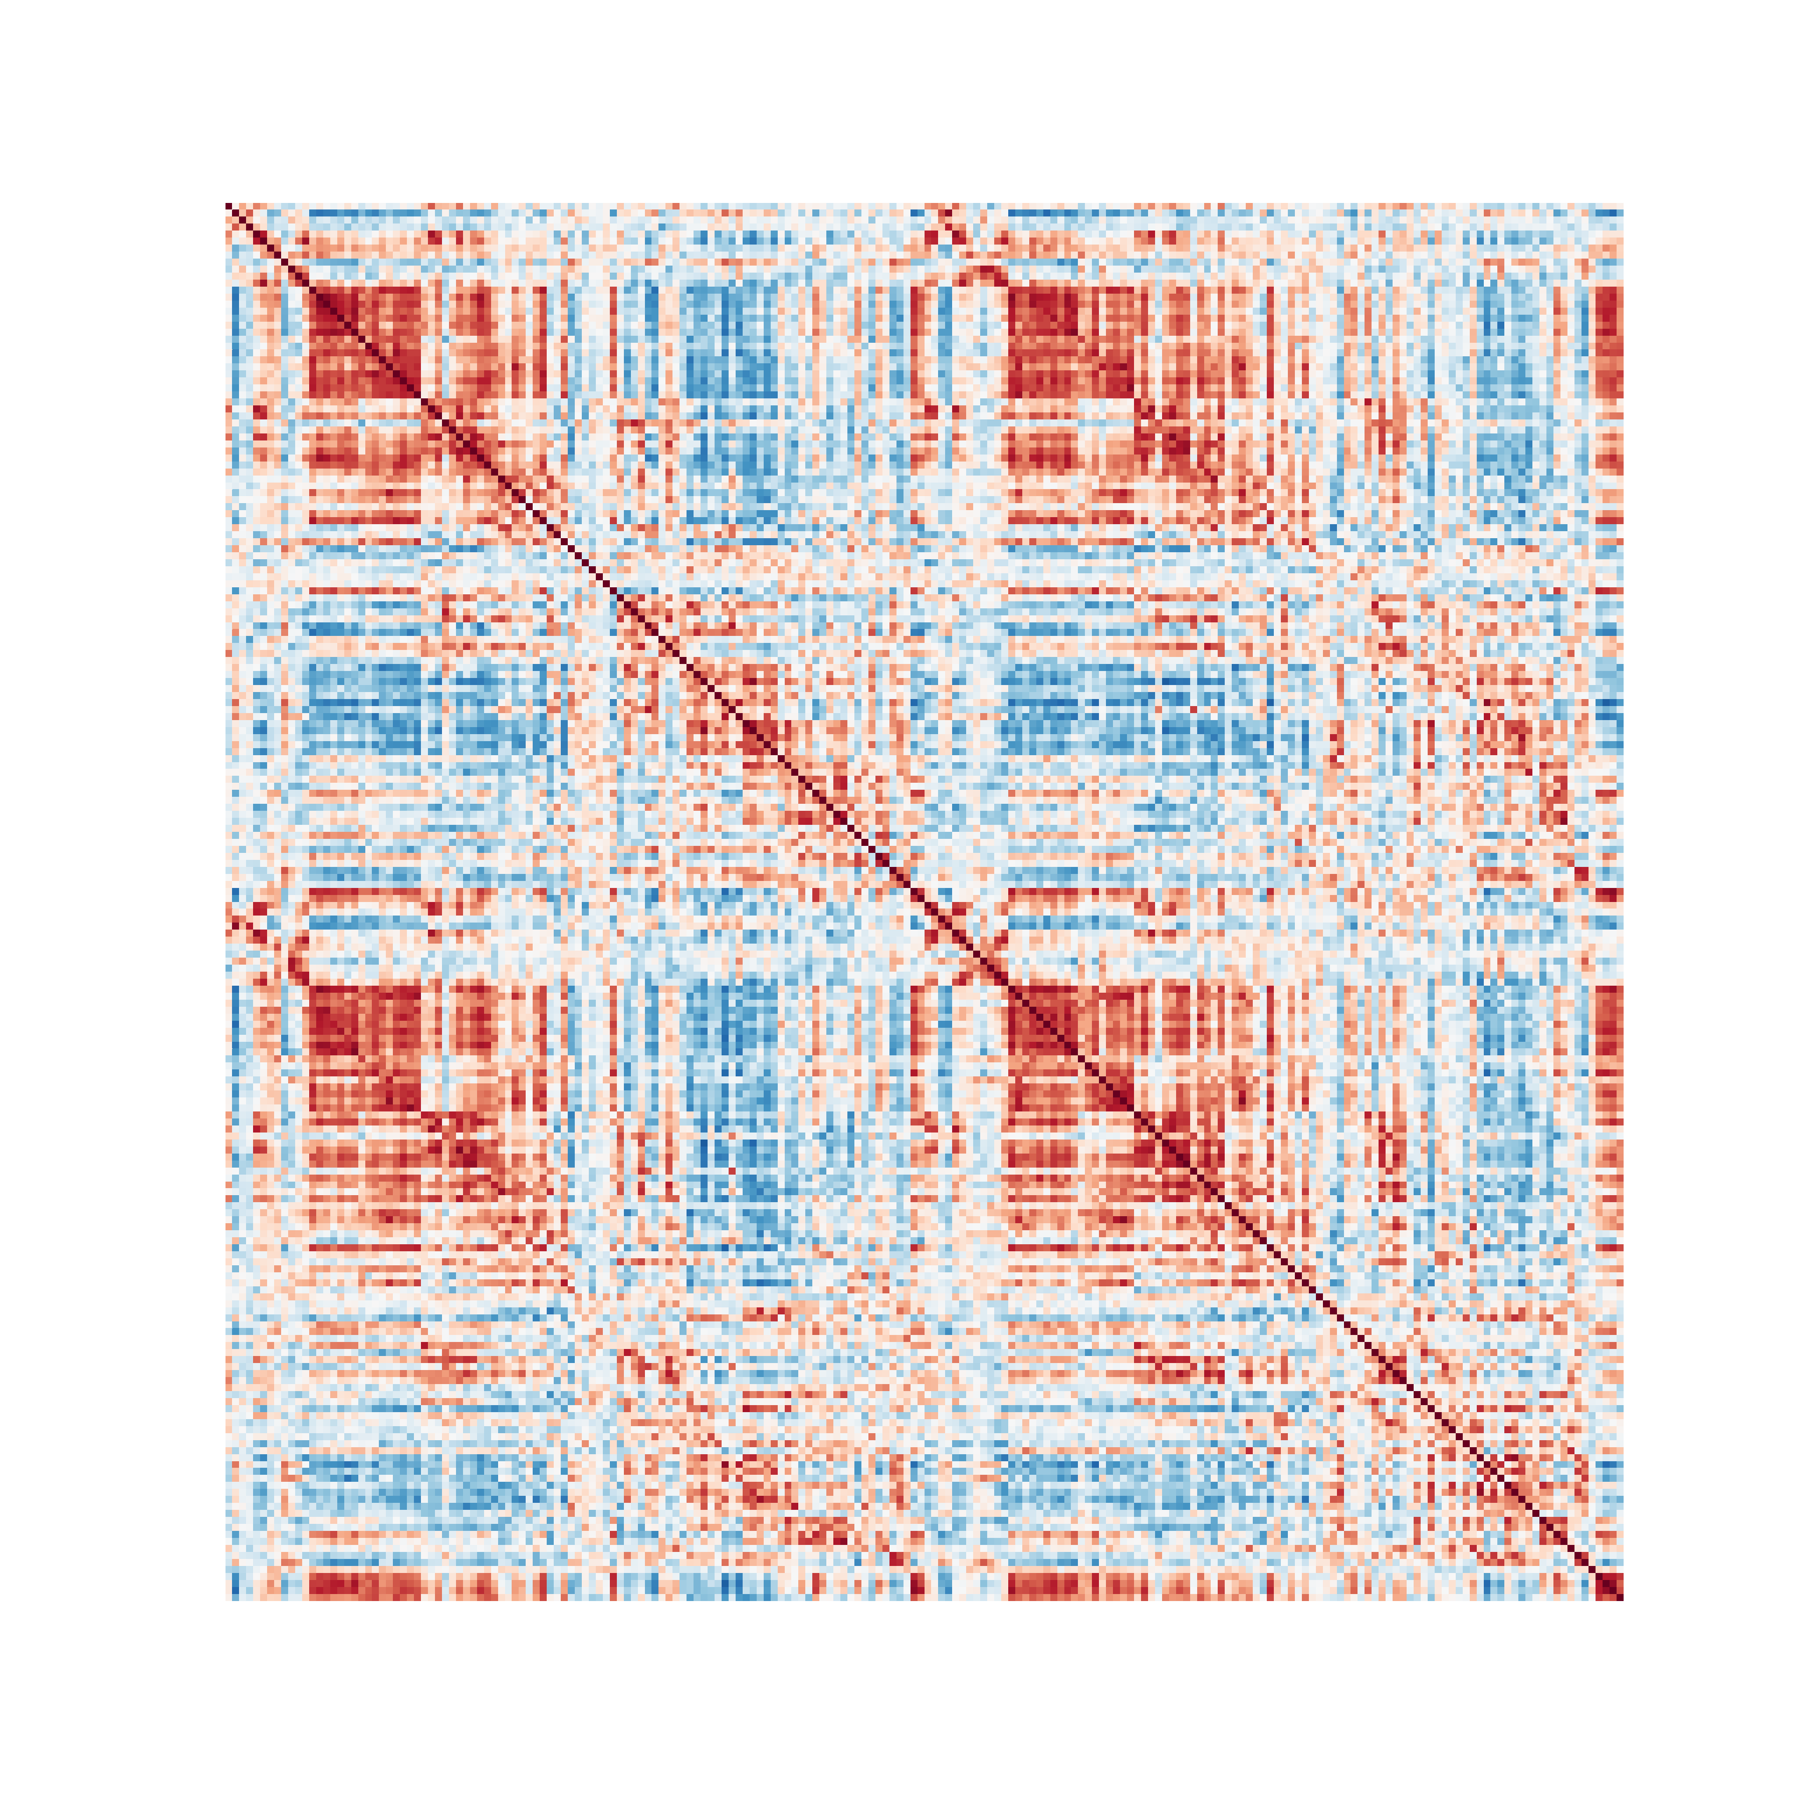

aa = plt.figure(figsize = [6,6])  
ax = sns.heatmap(corr_mats[:,:,9],   
 cmap = "RdBu_r",   
 vmin = -1,   
 vmax = 1,   
 square = True,   
 cbar = False)  
ax.axis('off')

> (0.0, 200.0, 200.0, 0.0)

ax.tick_params(left=False, bottom=False)  
   
plt.show()

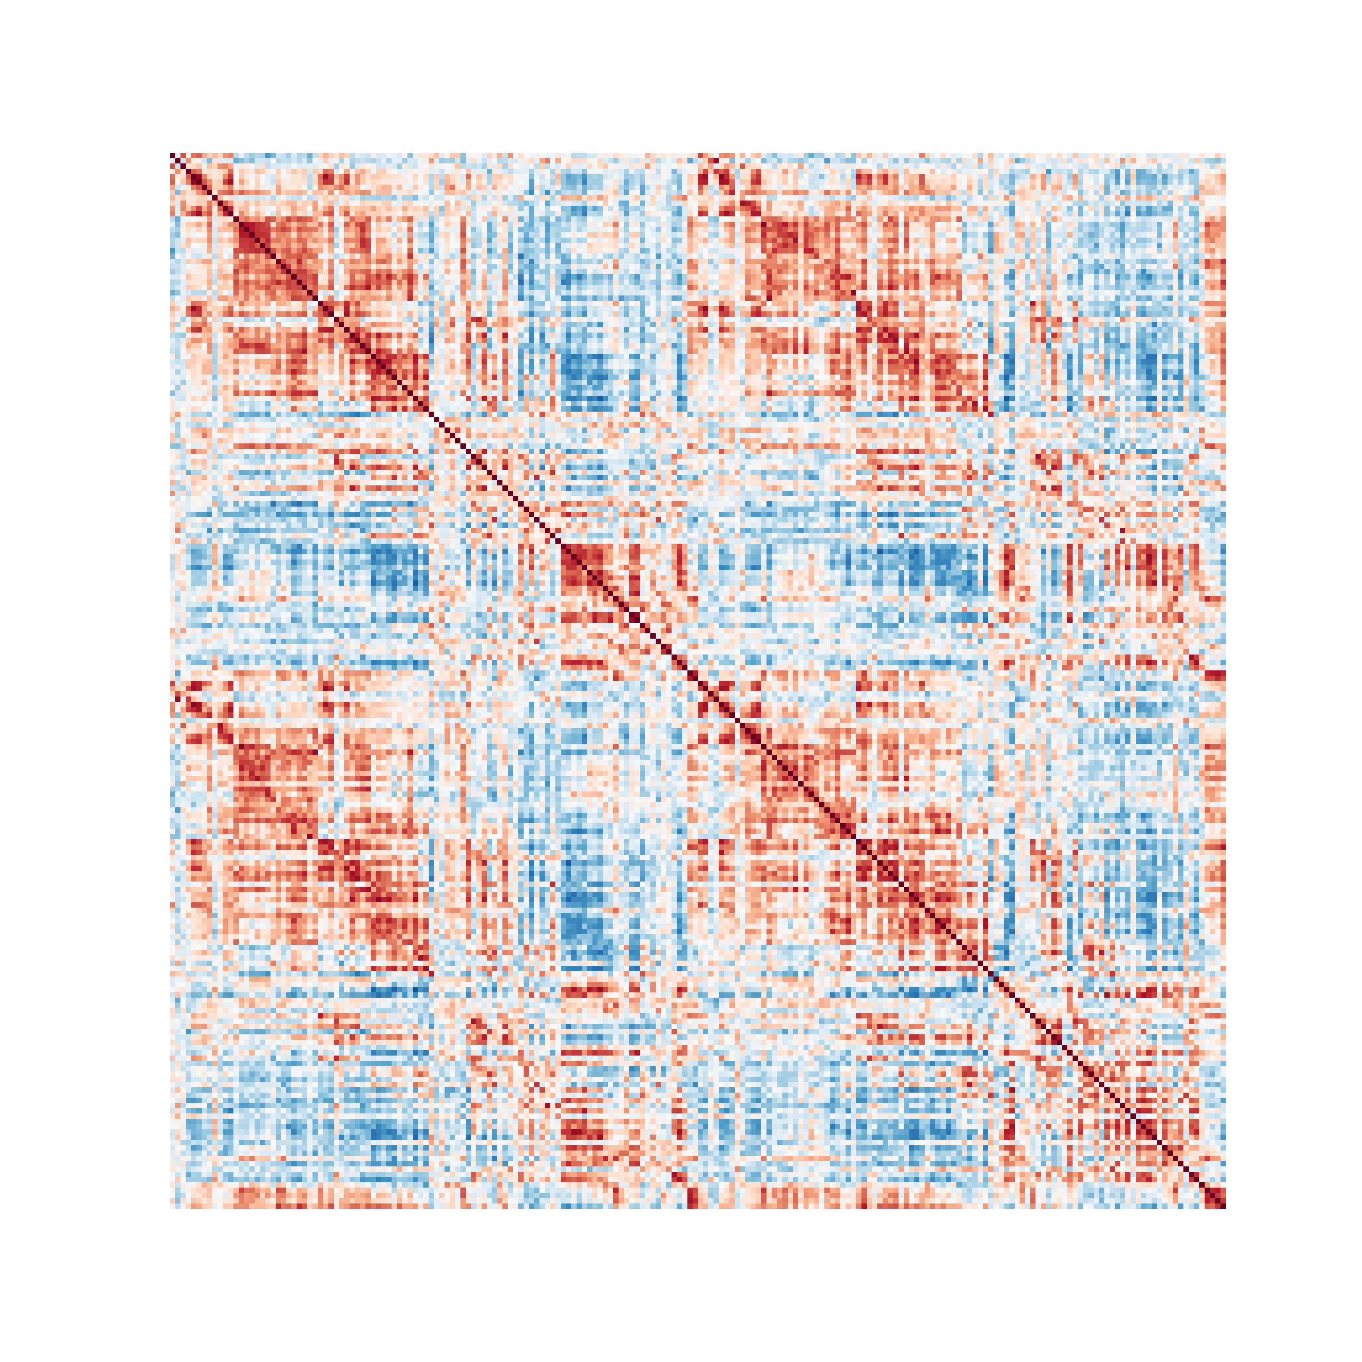

aa = plt.figure(figsize = [6,6])  
ax = sns.heatmap(corr_mats[:,:,16],   
 cmap = "RdBu_r",   
 vmin = -1,   
 vmax = 1,   
 square = True,   
 cbar = False)  
ax.axis('off')

> (0.0, 200.0, 200.0, 0.0)

ax.tick_params(left=False, bottom=False)  
   
plt.show()

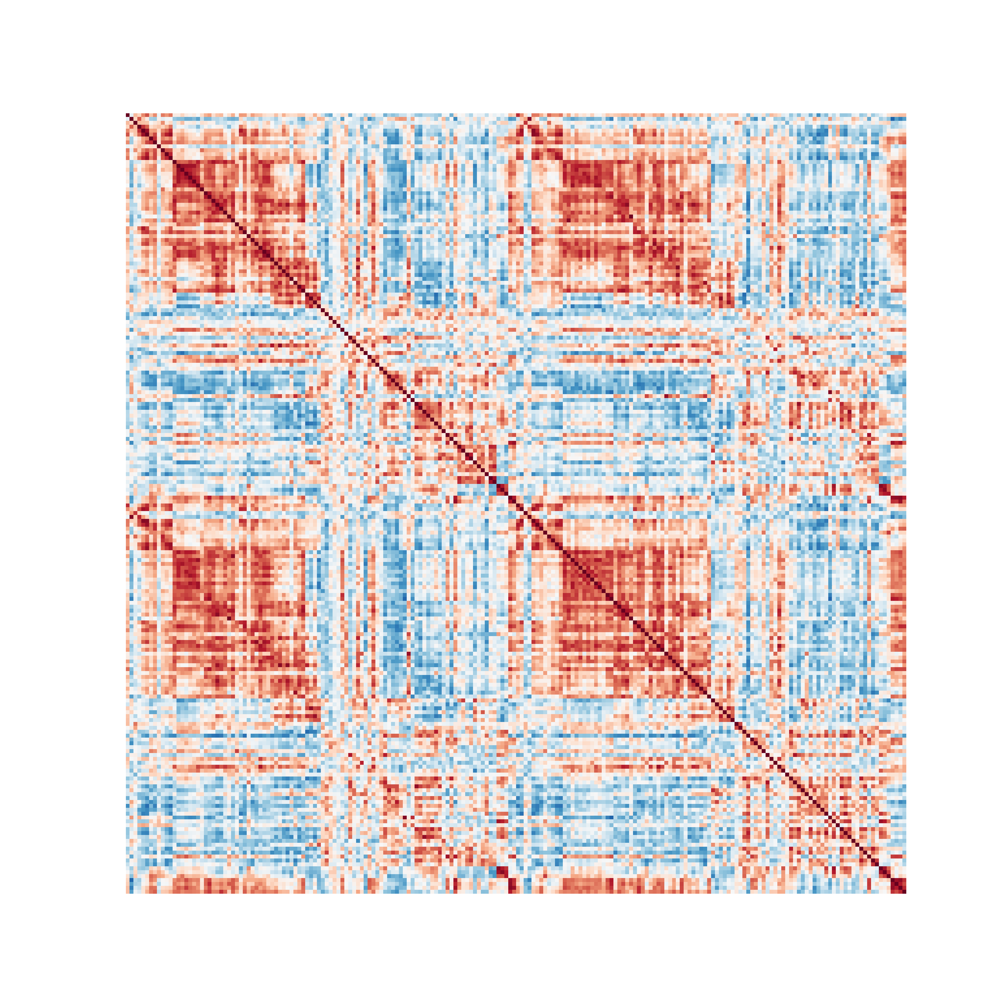

# 3 Cofluctuations

import sys  
sys.path.insert(1, 'libs/')  
  
import numpy as np  
import scipy as sc  
from scipy import io  
import dynfc as dyn  
import seaborn as sns  
import matplotlib.pyplot as plt  
  
ts = sc.io.loadmat('data/ts.mat')['ts']  
ts = ts.transpose()  
  
mat1, rss = dyn.corr_slide(ts,24)  
mat1 = mat1[:,:,0]  
  
aa = plt.figure(figsize = [6,6])  
ax = sns.heatmap(mat1,   
 cmap = "RdBu_r",   
 vmin = -1,   
 vmax = 1,   
 square = False,   
 cbar = True)  
ax.axis('off')

> (0.0, 200.0, 200.0, 0.0)

ax.tick_params(left=False, bottom=False)  
plt.show()

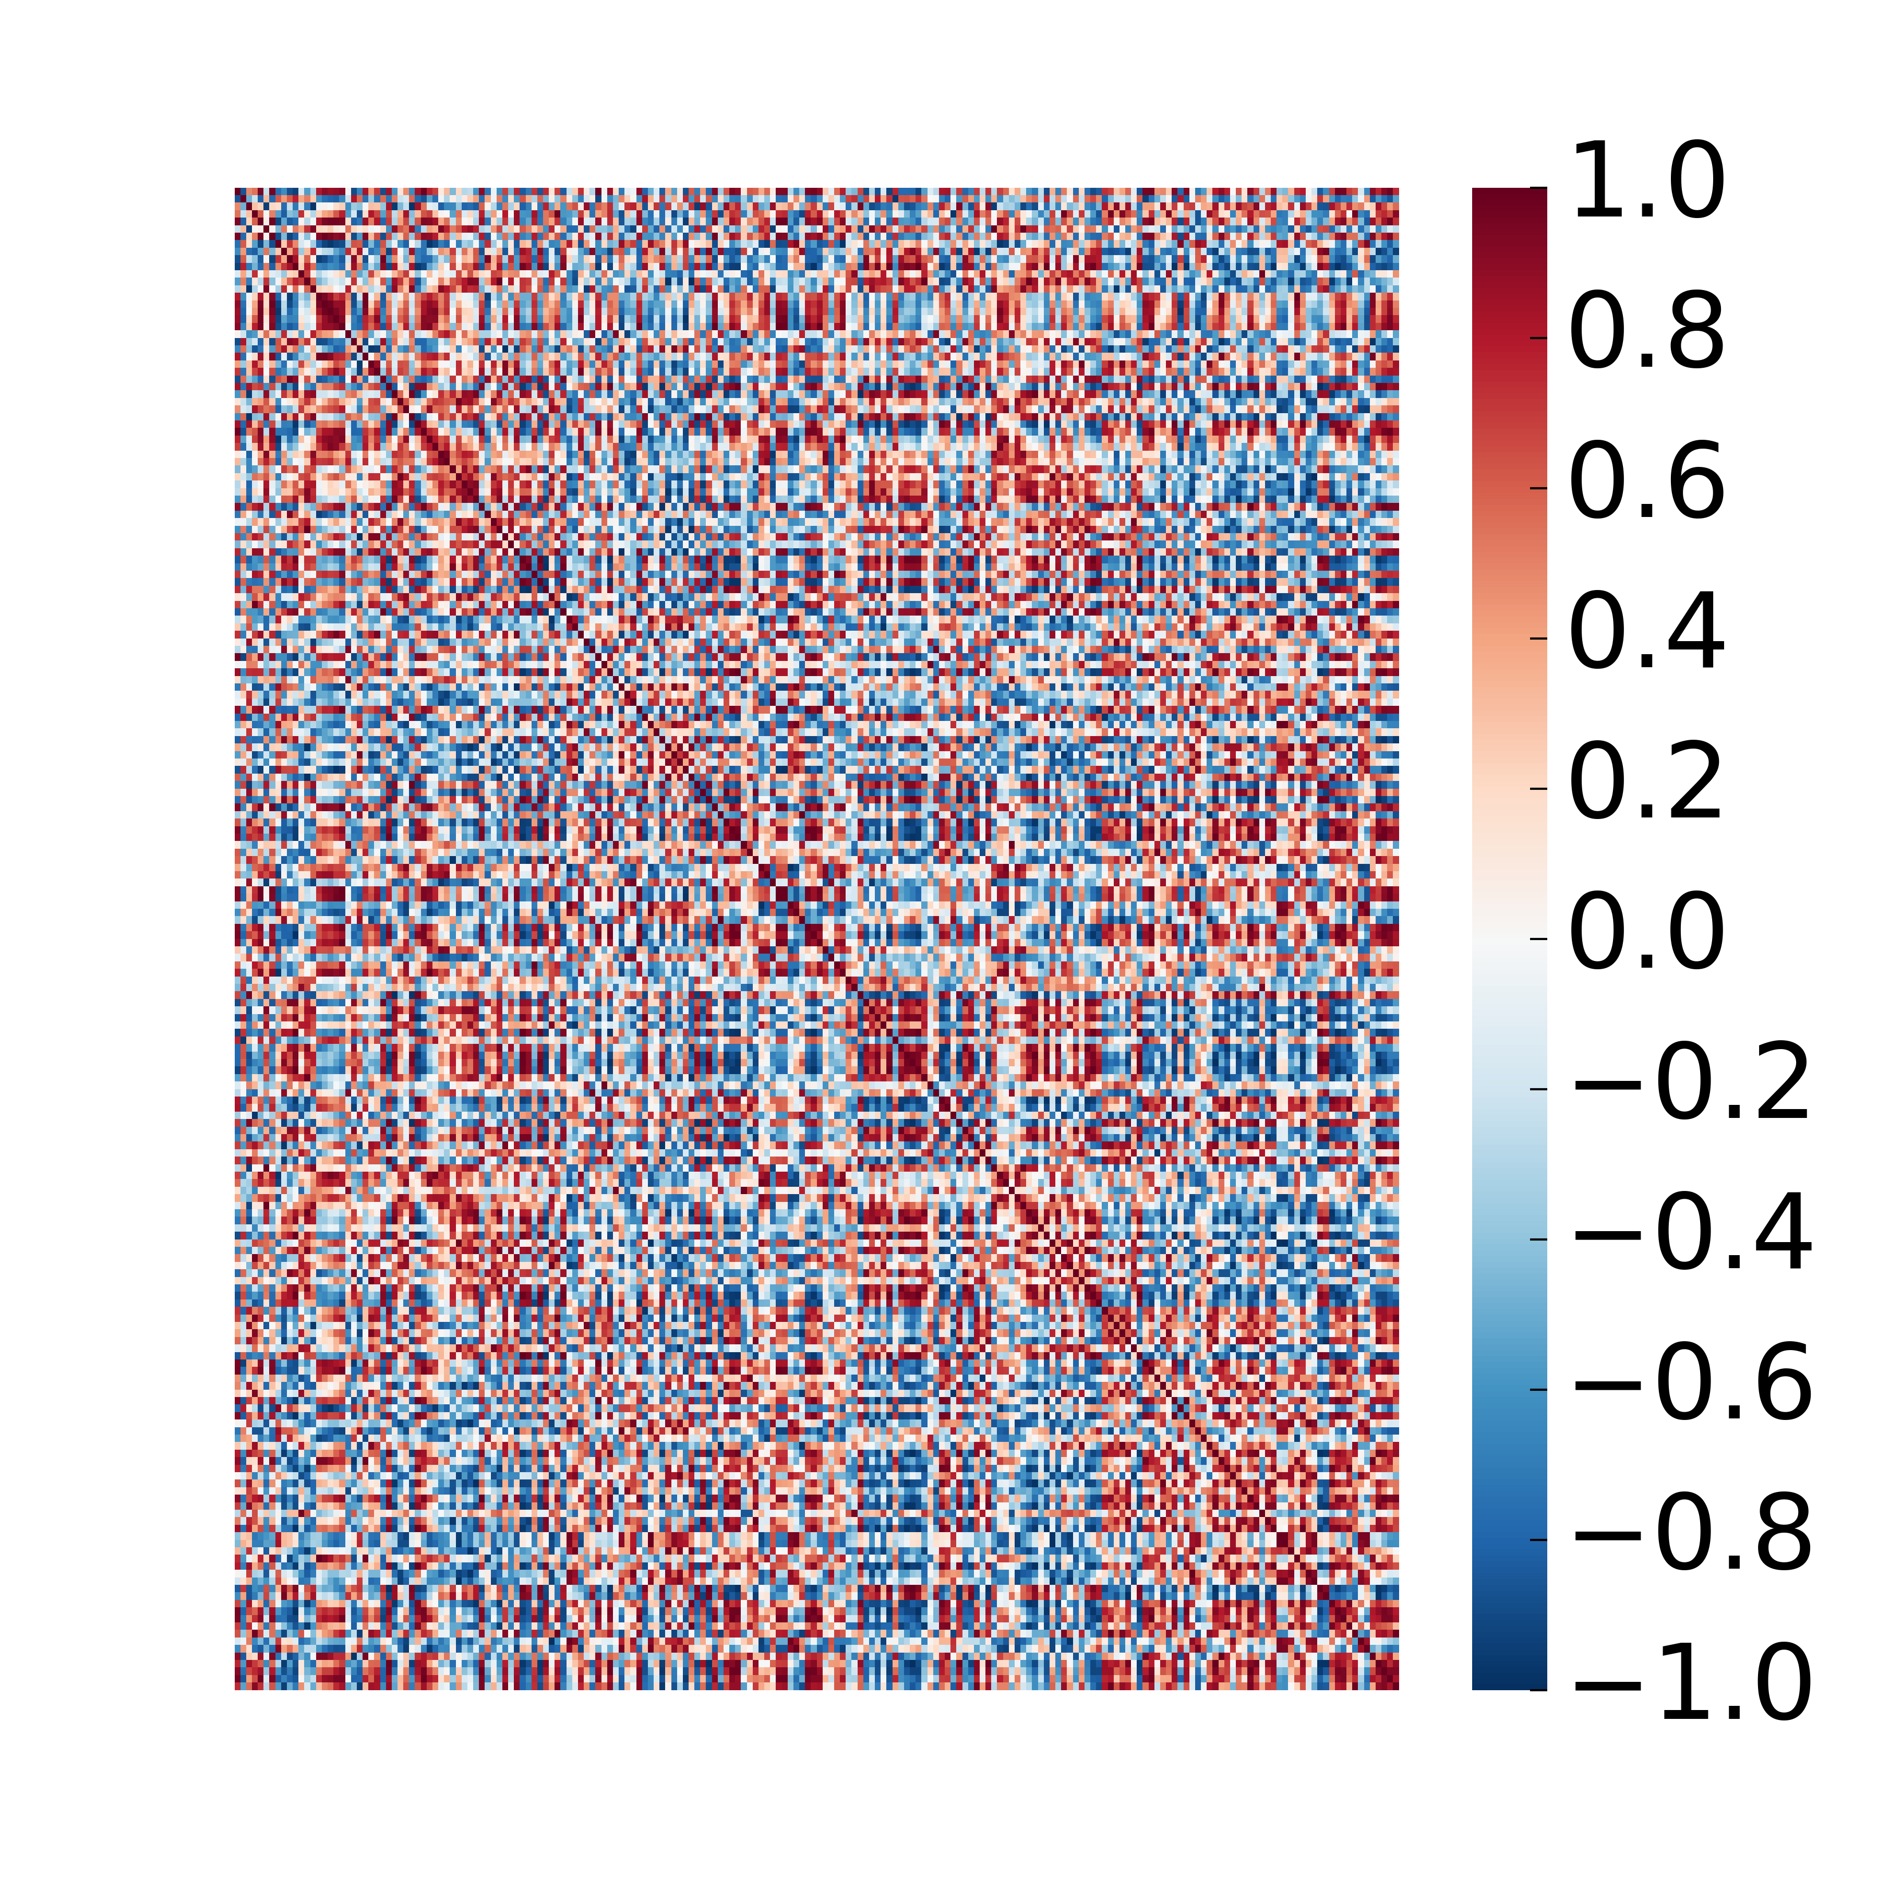

upt = np.triu_indices(mat1.shape[0], k = 1)  
vec = (mat1[upt])  
  
toPlot = np.zeros((vec.shape[0],1))  
toPlot[:,0] = vec  
  
aa = plt.figure(figsize = (12/50,4))  
ax = sns.heatmap(toPlot[:,0:1],   
 cmap = "RdBu_r",   
 vmin = -1,   
 vmax = 1,   
 square = False,   
 cbar = False)  
ax.axis('off')

> (0.0, 1.0, 19900.0, 0.0)

plt.show()



edges_series, corr_mats, rss = dyn.cofluct(ts, 24)  
  
aa = plt.figure(figsize = (12,4))  
ax = sns.heatmap(edges_series,   
 cmap = "RdBu_r",   
 vmin = -1,   
 vmax = 1,   
 square = False,   
 cbar = False)  
ax.axis('off')

> (0.0, 1200.0, 19900.0, 0.0)

plt.show()

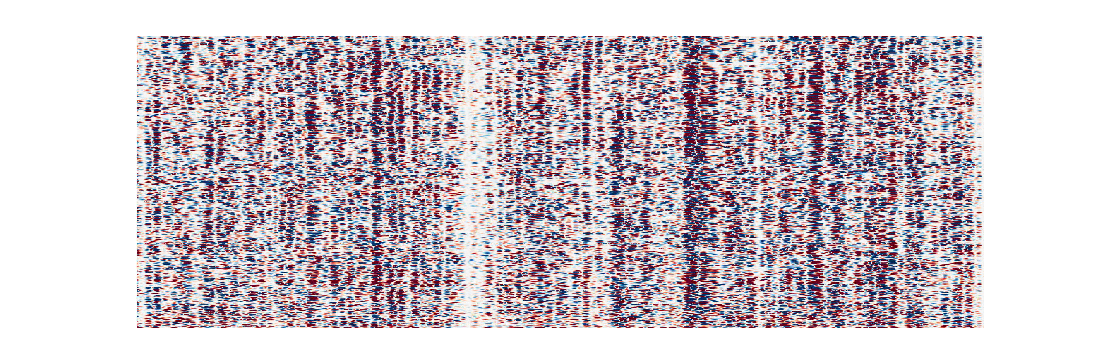

#Phase difference

import sys  
sys.path.insert(1, 'libs/')  
  
import numpy as np  
import matplotlib.pyplot as plt  
import matplotlib.patches as patches  
from mpl_toolkits.mplot3d import Axes3D  
  
theta = np.linspace(0*np.pi, 8*np.pi, 100)  
time = np.linspace(0, 8, 100)  
y1 = np.sin(theta)  
x1 = np.cos(theta)  
y2 = np.sin(theta + np.pi/2)  
x2 = np.cos(theta + np.pi/2)  
r = time/np.max(time)  
ones = np.ones(time.shape[0])  
  
fig = plt.figure()  
ax = fig.add_subplot(projection='3d')  
plt.style.use('classic')  
  
ax.plot(time, x1, y1, color = '#67001f', linewidth=2)

> [<mpl_toolkits.mplot3d.art3d.Line3D object at 0x7fc2ef1a14e0>]

ax.plot(time,ones,y1, linestyle = '--', color = '#0f0f0f')

> [<mpl_toolkits.mplot3d.art3d.Line3D object at 0x7fc2817ab0f0>]

ax.plot(time,x1,-ones, linestyle = '--', color = '#0f0f0f')

> [<mpl_toolkits.mplot3d.art3d.Line3D object at 0x7fc2817ab278>]

ax.quiver(time,0,0,0, 0.99*x1, 0.99*y1,   
 length = 0.9,   
 normalize = False,   
 arrow_length_ratio = 0.1,   
 alpha = 0.4,   
 color = '#053061')

> <mpl_toolkits.mplot3d.art3d.Line3DCollection object at 0x7fc2817aba58>

ax.text(0.5, 1, 0.5, r'$\sin(\theta)$', fontsize = 20)

> Text(0.5, 1, '$\\sin(\\theta)$')

ax.text(0.5, -1, -1, r'$\cos(\theta)$', fontsize = 20)

> Text(0.5, -1, '$\\cos(\\theta)$')

ax.set_xlabel('Time')

> Text(0.5, 0, 'Time')

ax.set_ylabel('Re')

> Text(0.5, 0, 'Re')

ax.set_zlabel('Im')

> Text(0.5, 0, 'Im')

ax.set_xlim(0,8)

> (0.0, 8.0)

ax.set_ylim(-1,1)

> (-1.0, 1.0)

ax.set_zlim(-1,1)

> (-1.0, 1.0)

plt.show()

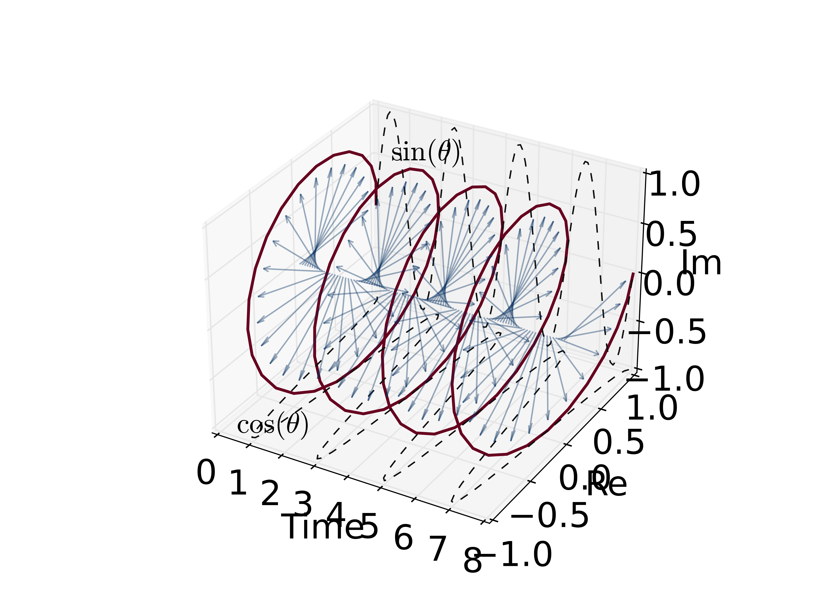

colors1 = plt.cm.Reds(np.arange(0,1,0.01))  
colors1[:,-1] = np.arange(0,1,0.01)  
  
colors2 = plt.cm.Blues(np.arange(0,1,0.01))  
colors2[:,-1] = np.arange(0,1,0.01)  
  
fig = plt.figure(figsize = (12,8))  
ax = fig.add_subplot(projection='3d')  
plt.style.use('classic')  
  
ax.scatter(time,ones,r*y1, color = colors1, marker = ",", s = 3)

> <mpl_toolkits.mplot3d.art3d.Path3DCollection object at 0x7fc2f0e7b390>

ax.scatter(time,r*x1,-ones, color = colors1, marker = ",", s = 3)

> <mpl_toolkits.mplot3d.art3d.Path3DCollection object at 0x7fc2eefa9ac8>

ax.scatter(time,ones,r*y2, color = colors2, marker = ",", s = 3)

> <mpl_toolkits.mplot3d.art3d.Path3DCollection object at 0x7fc2eefa99e8>

ax.scatter(time,r*x2,-ones, color = colors2, marker = ",", s = 3)  
#ax.plot(time,r*x2,-ones, linestyle = '--', color = colors2[-10,:])

> <mpl_toolkits.mplot3d.art3d.Path3DCollection object at 0x7fc2eefa9320>

ax.quiver(time,0,0,0, 0.99*r*x1, 0.99*r*y1,   
 length = 0.9,   
 normalize = False,   
 arrow_length_ratio = 0.1,   
 alpha = 1,   
 color = colors1)

> <mpl_toolkits.mplot3d.art3d.Line3DCollection object at 0x7fc2409f1cf8>

ax.quiver(time,0,0,0, 0.99*r*x2, 0.99*r*y2,   
 length = 0.9,   
 normalize = False,   
 arrow_length_ratio = 0.1,   
 alpha = 1,   
 color = colors2)

> <mpl_toolkits.mplot3d.art3d.Line3DCollection object at 0x7fc2f0b2ea58>

ax.text(0.5, 1, 0.4, r'$A(t)$ $\sin(\theta)$', fontsize = 20)

> Text(0.5, 1, '$A(t)$ $\\sin(\\theta)$')

ax.text(0.5, -0.9, -1, r'$A(t)$ $\cos(\theta)$', fontsize = 20)

> Text(0.5, -0.9, '$A(t)$ $\\cos(\\theta)$')

ax.set_xlabel('Time')

> Text(0.5, 0, 'Time')

ax.set_ylabel('Re')

> Text(0.5, 0, 'Re')

ax.set_zlabel('Im')

> Text(0.5, 0, 'Im')

ax.set_xlim(0,8)

> (0.0, 8.0)

ax.set_ylim(-1,1)

> (-1.0, 1.0)

ax.set_zlim(-1,1)

> (-1.0, 1.0)

plt.show()

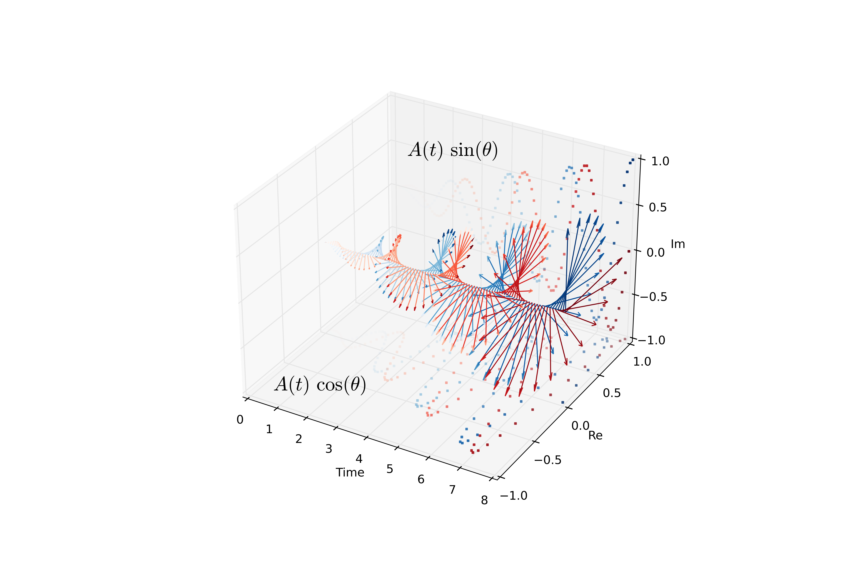

x1_vec = x1  
x1_vec = x1_vec[99]  
y1_vec = y1  
y1_vec = y1_vec[99]  
  
x2_vec = x2  
x2_vec = x2_vec[99]  
y2_vec = y2  
y2_vec = y2_vec[99]  
  
x, y = 0.0, 0.0  
  
fig,ax = plt.subplots(1)  
fig.set_figheight(6)  
fig.set_figwidth(7)  
ax.scatter(r*x1,r*y1, color = colors1, marker = ".", s = 100)

> <matplotlib.collections.PathCollection object at 0x7fc382a2a630>

ax.scatter(r*x2,r*y2, color = colors2, marker = ".", s = 100)

> <matplotlib.collections.PathCollection object at 0x7fc2eef6cc88>

ax.arrow(0,0,x1_vec,y1_vec, width = 0.015, color = colors1[-1,:], head_width = 0.1)

> <matplotlib.patches.FancyArrow object at 0x7fc382a44a90>

ax.arrow(0,0,x2_vec,y2_vec, width = 0.015, color = colors2[-1,:], head_width = 0.1)

> <matplotlib.patches.FancyArrow object at 0x7fc2eef6c358>

ax.add_patch(patches.Arc((x,y), 2.3, 2.3, theta1=0.0, theta2=90.0, linestyle = '--'))

> <matplotlib.patches.Arc object at 0x7fc389b0d320>

ax.text(0.7,1, r'$\mathcal{\Delta\varphi = \frac{\pi}{2}}$', fontsize = 24)

> Text(0.7, 1, '$\\mathcal{\\Delta\\varphi = \\frac{\\pi}{2}}$')

ax.text(1.18*x1_vec,y1_vec, r'$\mathcal{\varphi}_{1}$', fontsize = 20)

> Text(1.18, -9.797174393178826e-16, '$\\mathcal{\\varphi}_{1}$')

ax.text(x2_vec,1.22*y2_vec, r'$\mathcal{\varphi}_{2}$', fontsize = 20)

> Text(-7.354070601250002e-16, 1.22, '$\\mathcal{\\varphi}_{2}$')

ax.set_xlim(-1.35,1.35)

> (-1.35, 1.35)

ax.set_ylim(-1.35,1.35)

> (-1.35, 1.35)

ax.set_xlabel('Re')

> Text(0.5, 0, 'Re')

ax.set_ylabel('Im')

> Text(0, 0.5, 'Im')

plt.show()

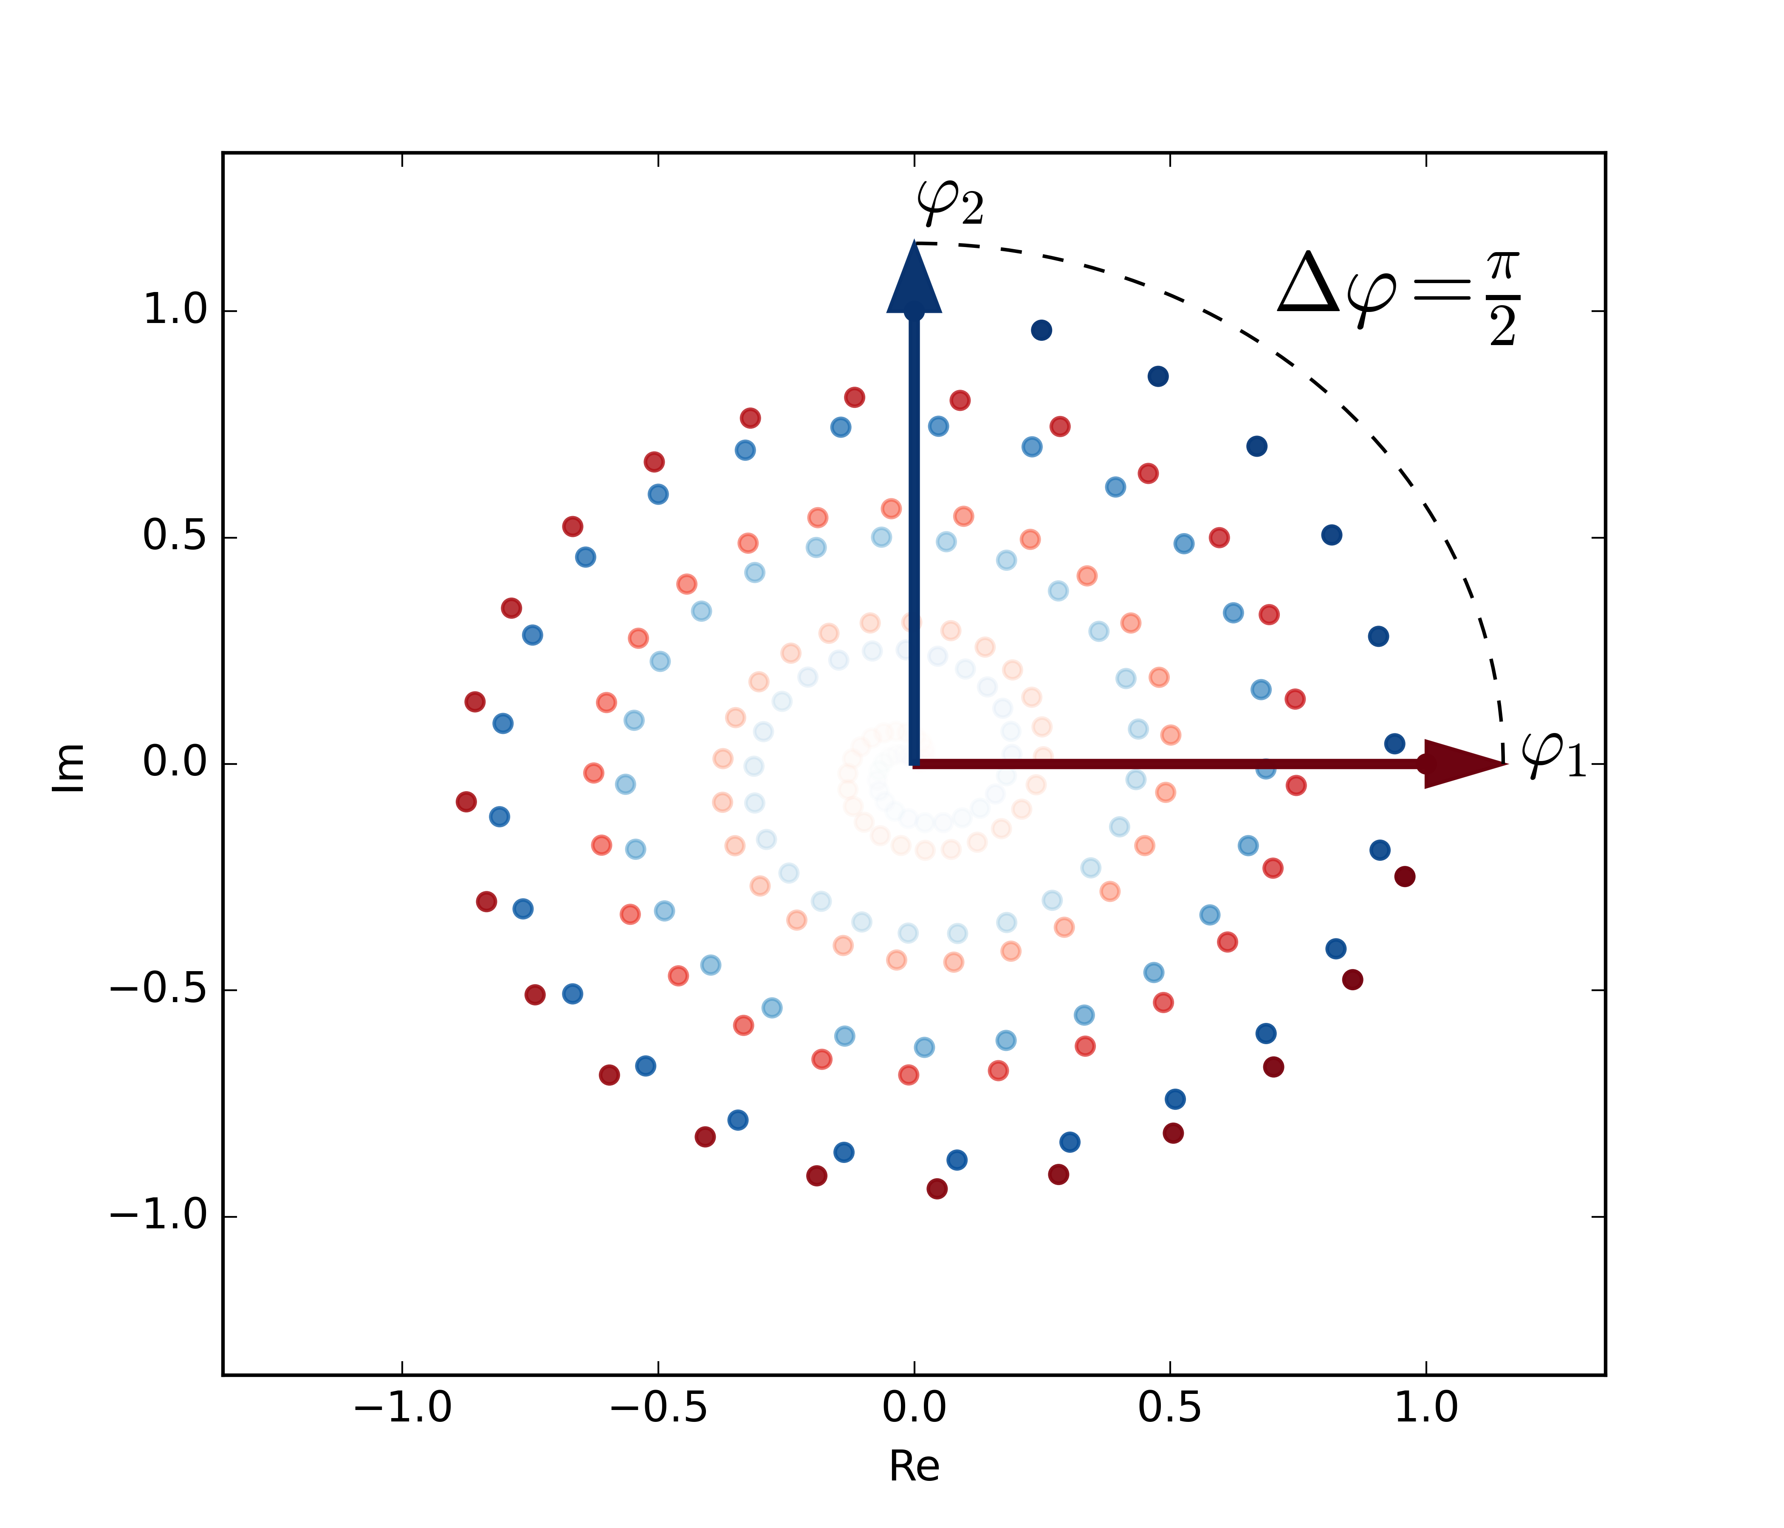

import sys  
sys.path.insert(1, 'libs/')  
  
import numpy as np  
import scipy as sc  
from scipy import io  
import dynfc as dyn  
import seaborn as sns  
import matplotlib.pyplot as plt  
  
ts = sc.io.loadmat('data/ts.mat')['ts']  
ts = ts  
  
RSsig = np.zeros((ts.shape[0],ts.shape[1],1))  
RSsig[:,:,0] = ts  
  
Phases, syncConn, leidaArray = dyn.run_multiPat(RSsig)

> Signal filtered.  
> Phases obtained.  
> Matrices obtained.  
> Routine finished for patient no. 1.

mat1 = syncConn[:,:,0,0]  
  
aa = plt.figure(figsize = [7,6])  
ax = sns.heatmap(mat1,   
 cmap = "RdBu_r",   
 vmin = -1,   
 vmax = 1,   
 square = True,   
 cbar = True)  
ax.axis('off')

> (0.0, 200.0, 200.0, 0.0)

ax.tick_params(left=False, bottom=False)  
plt.show()

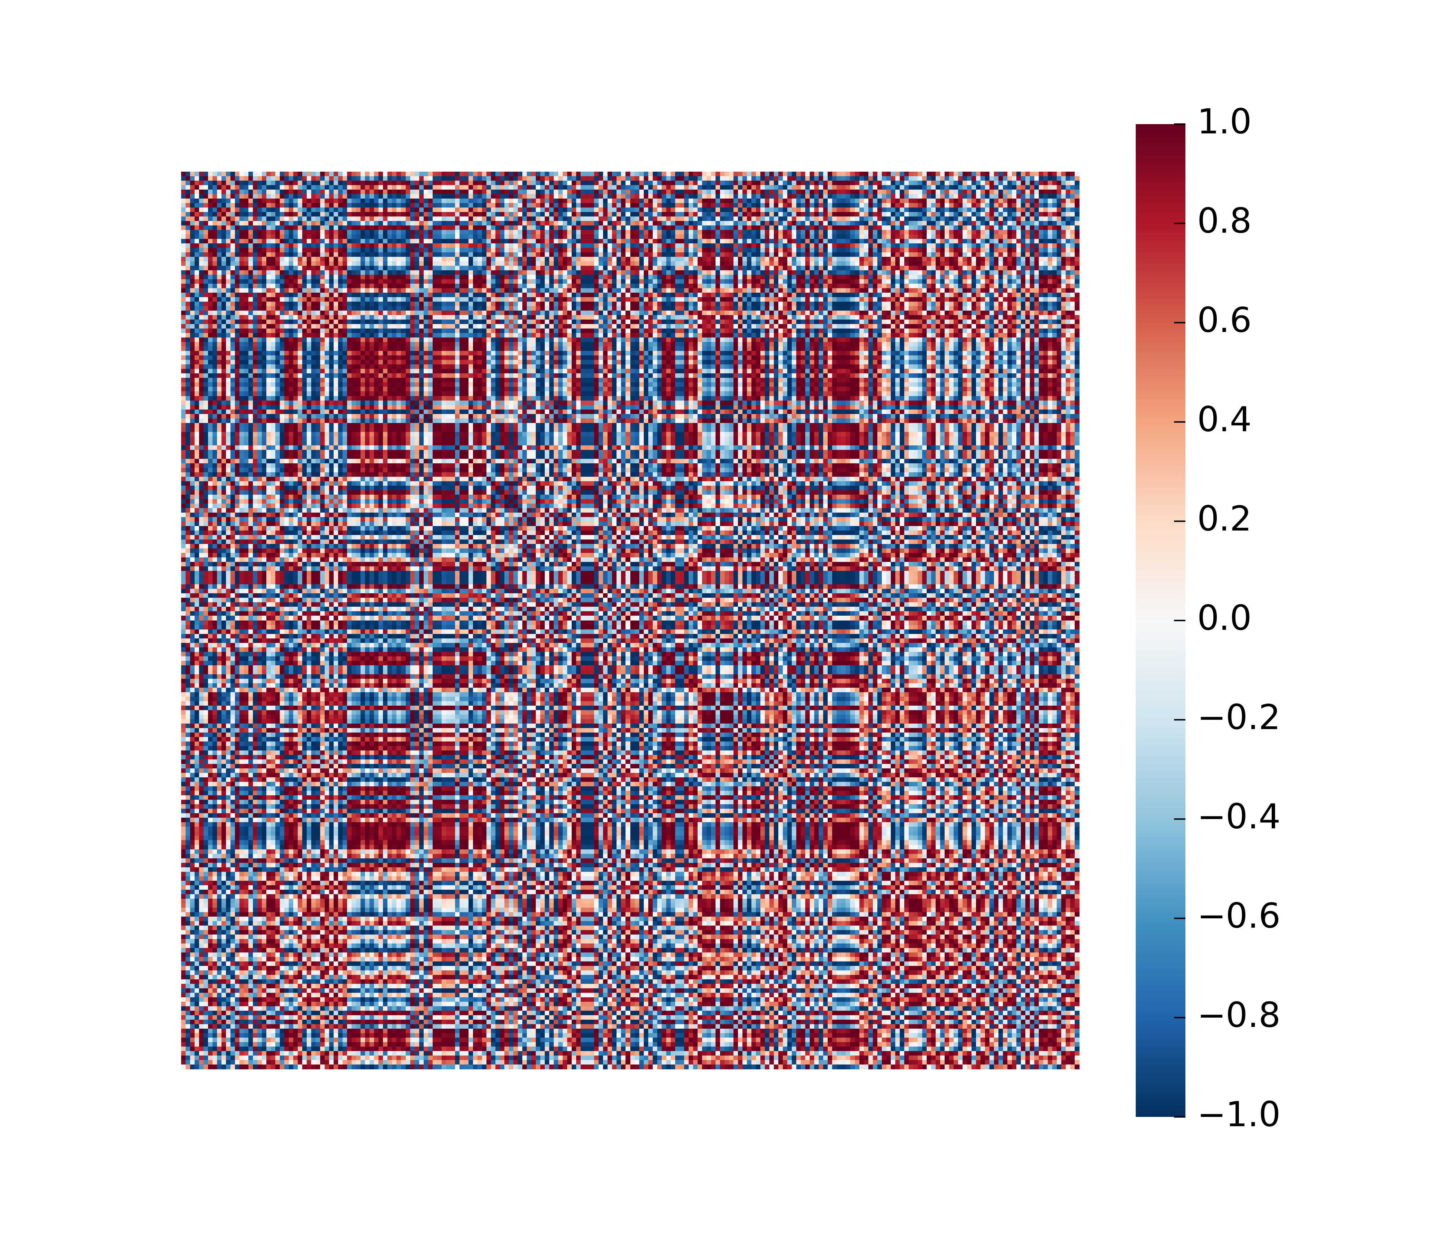

aa = plt.figure(figsize = (12/50,4))  
ax = sns.heatmap(leidaArray[:,0,]/max(abs(leidaArray[:,0,])),   
 cmap = "RdBu_r",   
 vmin = -1,   
 vmax = 1,   
 square = False,   
 cbar = False)  
ax.axis('off')

> (0.0, 1.0, 1180.0, 0.0)

plt.show()



This document was prepared on 2021-02-14.

# 4 Package References

report::cite_packages(sessionInfo())

* JJ Allaire and Yihui Xie and Jonathan McPherson and Javier Luraschi and Kevin Ushey and Aron Atkins and Hadley Wickham and Joe Cheng and Winston Chang and Richard Iannone (2020). rmarkdown: Dynamic Documents for R. R package version 2.6. URL <https://rmarkdown.rstudio.com>.
* Kevin Ushey, JJ Allaire and Yuan Tang (2021). reticulate: Interface to ‘Python’. R package version 1.18-9007. <https://github.com/rstudio/reticulate>
* R Core Team (2020). R: A language and environment for statistical computing. R Foundation for Statistical Computing, Vienna, Austria. URL <https://www.R-project.org/>.